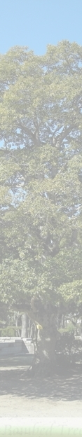
Application Form
PartⅠ

Date (day/month/year)

- Name:

- Address:

- Country:

4. How can you be contacted?
1) Telephone:
2) Fax:
3) E-mail:
4) Website:

5. Professional affiliation:

6. Have you ever participated in any UNITAR or ANT-Hiroshima workshops?
Yes (details):

No

7. Have you ever visited Hiroshima?
Yes (when?):

No

8. Motivation for applying:

9. Location where you want to plant: (If you are not certain yet, please indicate.)

Application Form
PartⅡ

10. Condition of the planting location and surrounding area's environment. Please share your ideas and plan as to how the tree(s) will be practically taken care of.

11. Please attach a photograph of the location where you want to plant the tree(s) and any further information and documents you may consider relevant.

12. Would you be able to provide regular (e.g. semi-annual) updates regarding the tree(s)?

Contacts: Green Legacy Hiroshima Team
Nassrine Azimi (greenlegacy@unitar.org) and Tomoko Watanabe (green@ant-hiroshima.org), Coordinators

www.unitar.org/greenlegacyhiroshima

