Programme Performance Report 2014-2015

The Programme Performance Report for the 2014-2015 Biennium presents the results of the fourth performance reporting exercise that UNITAR has undertaken since results-based programme budgeting was introduced in 2008. The report compiles performance information from all UNITAR offices, programmes, sections and units (collectively, divisions) specifying expected results in the revised 2014-2015 programme budget, in accordance with the respective high-level programme and functional objectives. In addition to recording an assessment of expected accomplishments, the report also includes ratings against output targets and lists any non-programmed results (i.e. outcomes or outputs not included in the revised budget) that have been achieved.

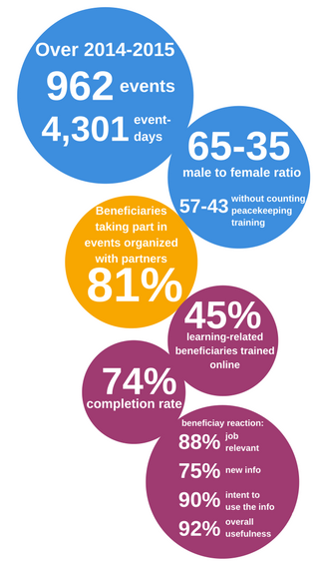

UNITAR’s key achievements

This report records actual programme performance against planned performance based on the indicators of achievement (outcomes) and planned outputs of the revised 2014-2015 programme budget.

Out of the 138 outcome indicators, 51 per cent were recorded as either having been surpassed or met within 10 percent of target, while 19 per cent were partially achieved and 17 per cent were not achieved.

Out of the 169 planned outputs, 60 per cent were recorded as either having been surpassed or met within 10 percent of target, while 27 per cent were not achieved.
A number of outcome and output indicators were not measured, and 30 non-programmed results accomplishments/outputs were reported.

Events breakdown:

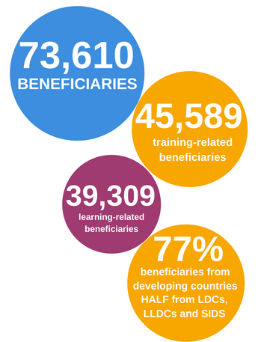Leading output: beneficiaries
Trained beneficiaries are by far the Institute’s leading, final output. Over the course of the 2014-2015 budget cycle, UNITAR registered a record number of 73,610 beneficiaries, exceeding by far the number of planned beneficiary outputs in the programme budget and representing the greatest outreach ever recorded in the history of the Institute. Beneficiaries from training-related events numbered 45,589, while the number of knowledge-sharing beneficiaries registered from conferences, side events and public lectures and other was 28,021.

Seventy-seven per cent of training-related beneficiaries came from developing countries, with approximately half of this grouping represented by beneficiaries from countries in special situations, including the Least Developed Countries, the Landlocked Developing Countries and the Small Island Developing States. The overall male to female ratio for the biennium was 65 to 35 (and 57 to 43 without counting peacekeeping training).

What are the performance challenges? Lessons to be learned?
Performance challenges explain non-achievement or under-achievement of planned results, and include external and internal factors related to the contextual environment in which UNITAR operates.
Performance challenges
External factors include:
- the delay, decrease or withdrawal of committed donor funding;
- the delay in project delivery by implementing partners funded through grant arrangements;
- uncertainty due to the proposed consolidation of the United Nations research and training institutes;
- the migration of the Secretariat’s Integrated Management and Information System (IMIS) ERP system to Umoja, requiring UNITAR to quickly identify an ERM solution meeting its organizational particularities and needs.

Internal factors include:
- human resource-related events or constraints;
- administrative and finance-related factors;
- organization-related factors;
- programme planning-related factors.

Lessons to be learned :
- In many external environments in which the Institute operates, close monitoring of ‘on-the-ground’ political, security and other realities, risk management and flexibility are crucial to effective programming;
- Sufficient technical expertise should be integrated in the design stages of projects, particularly those requiring IT or other technical inputs;
- Project monitoring should regularly be undertaken in the event of implementation challenges or staff changes to project or programme personnel;
- Financial reporting should be minimized to the extent possible for small scale projects, given the limited capacity of the Institute’s Finance and Budget Section and the large number of earmarked projects requiring financial reporting;
To read the full report, please visit : https://unitaremail.sharepoint.com/unitarnet/Documents/2014-2015%20PPR%20Compilation.pdf

